Ideas List
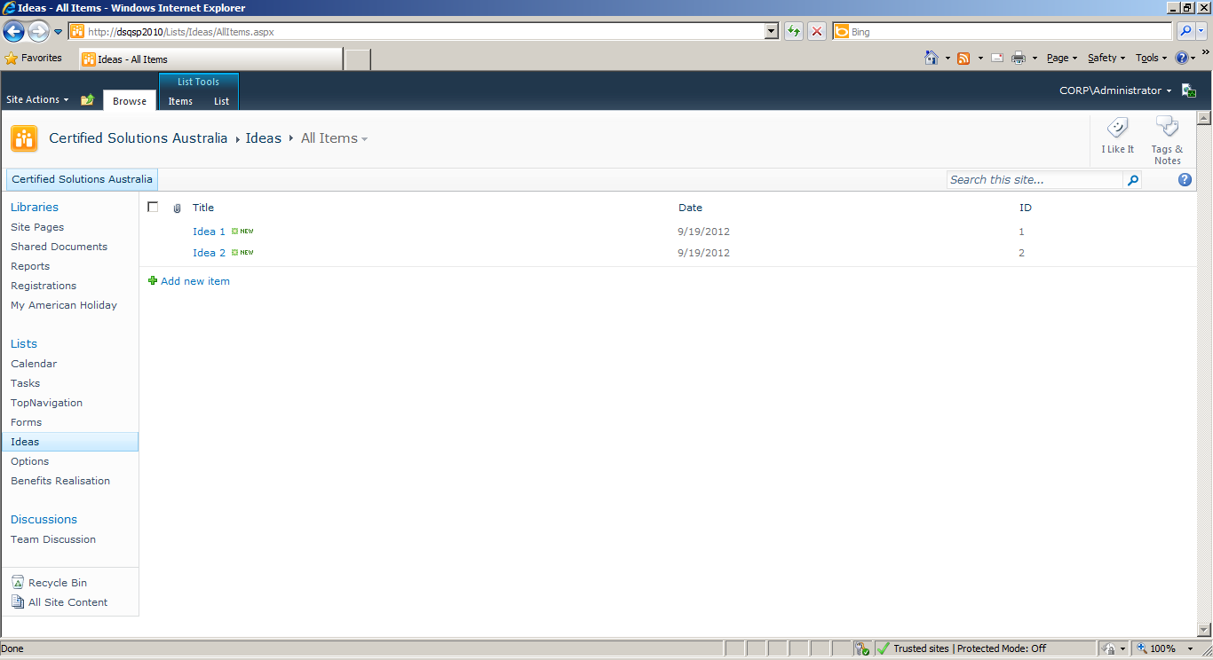
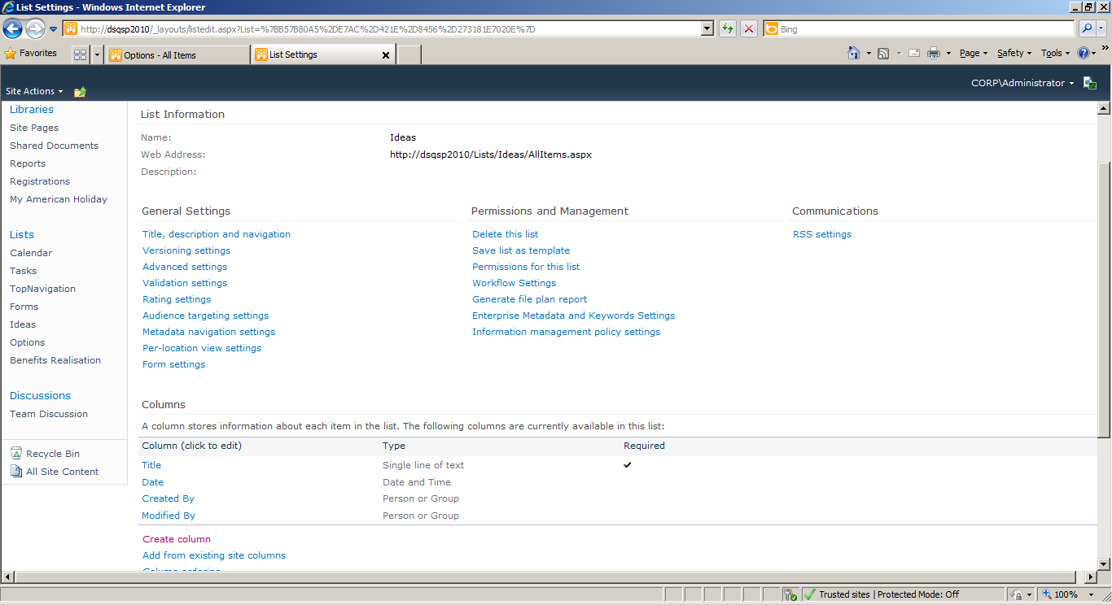

Options List
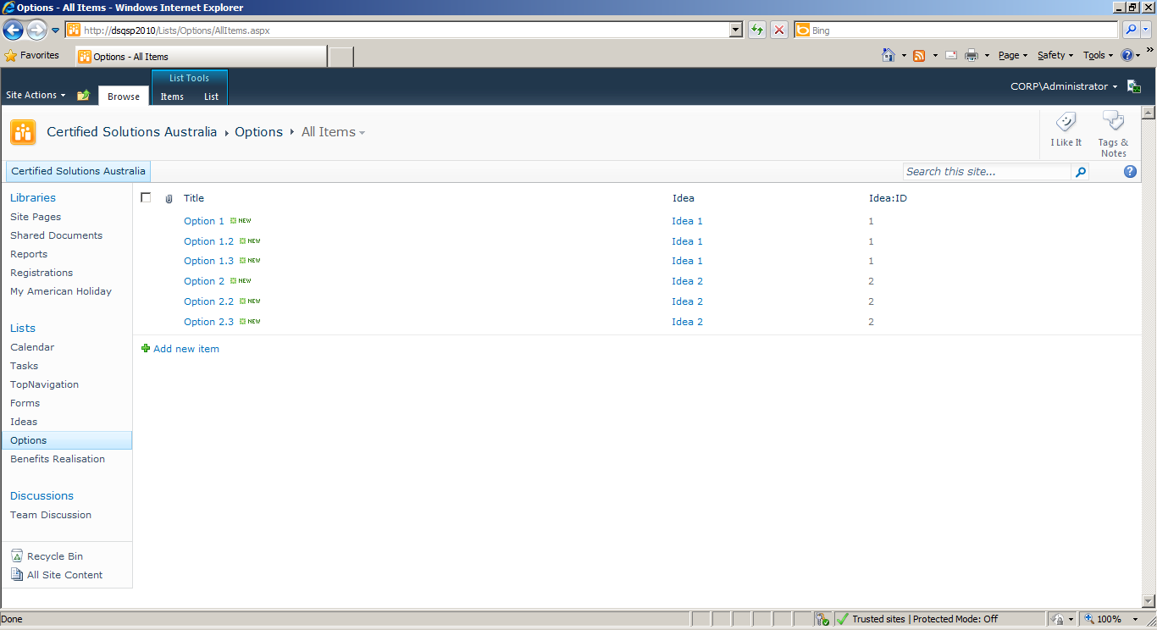
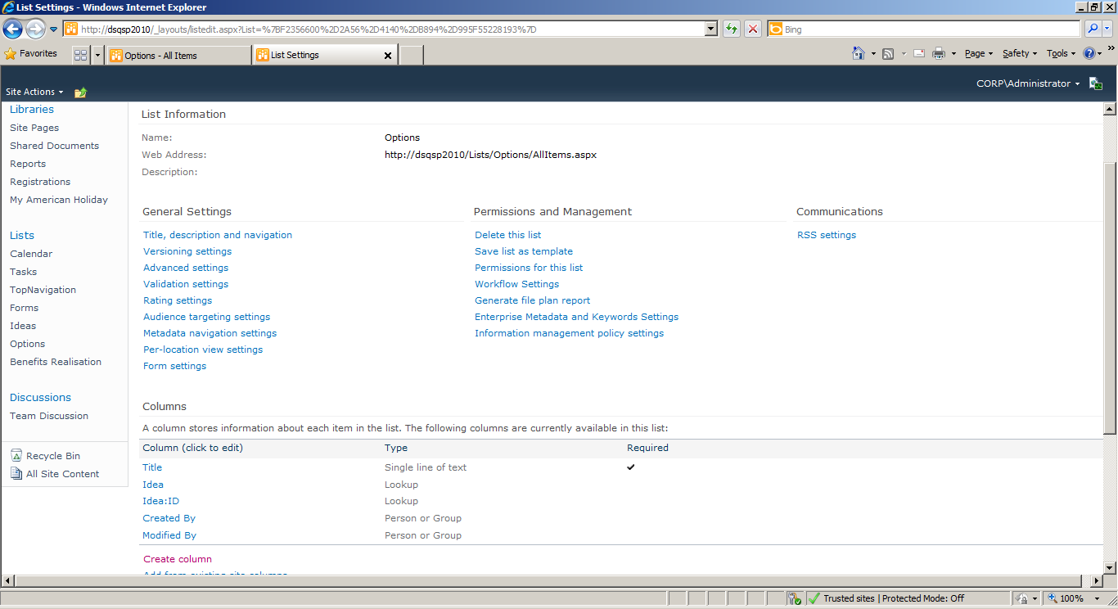
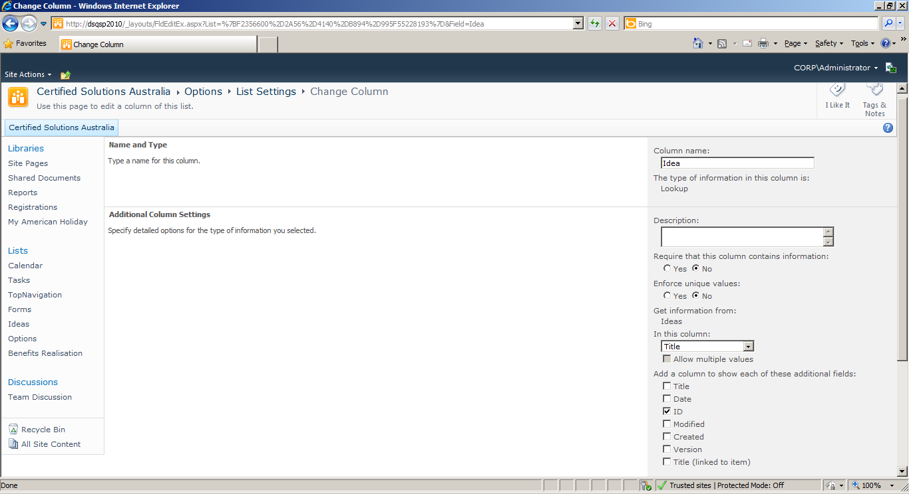

Benefits Realisation List
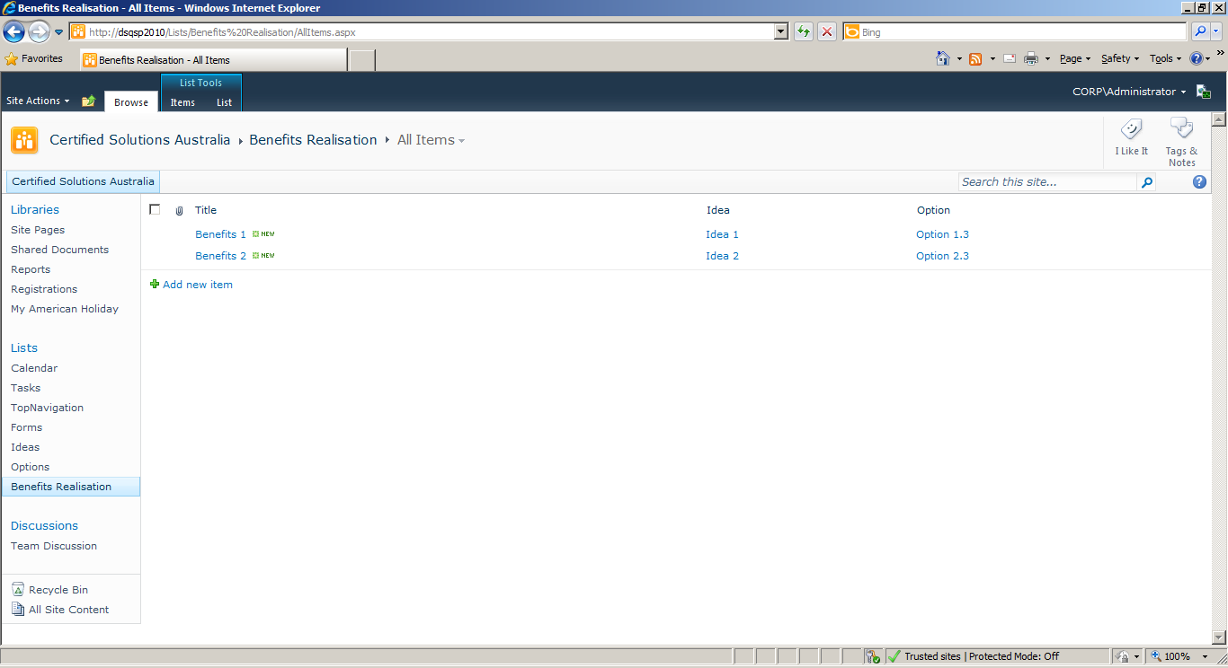
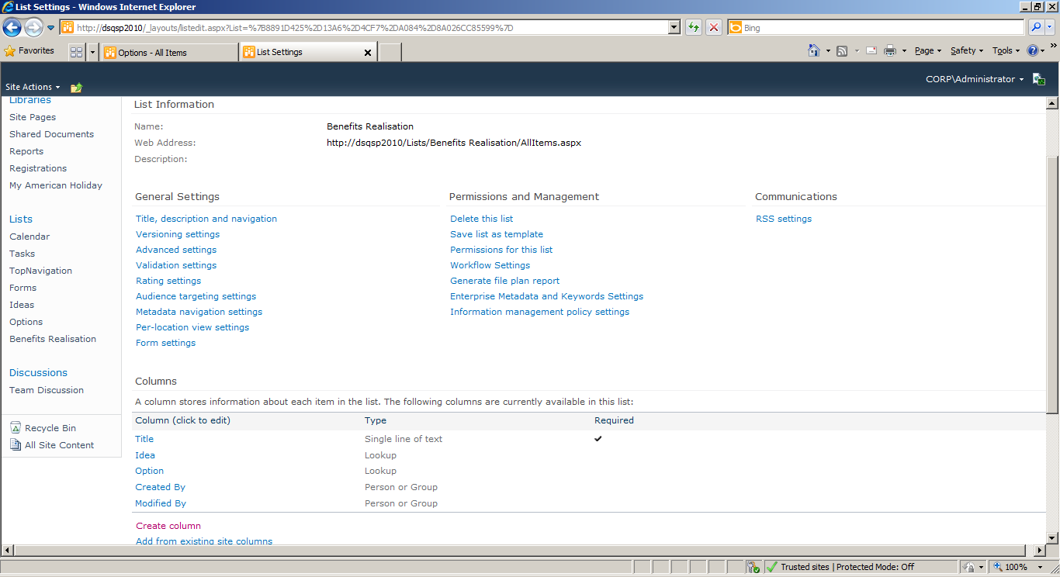
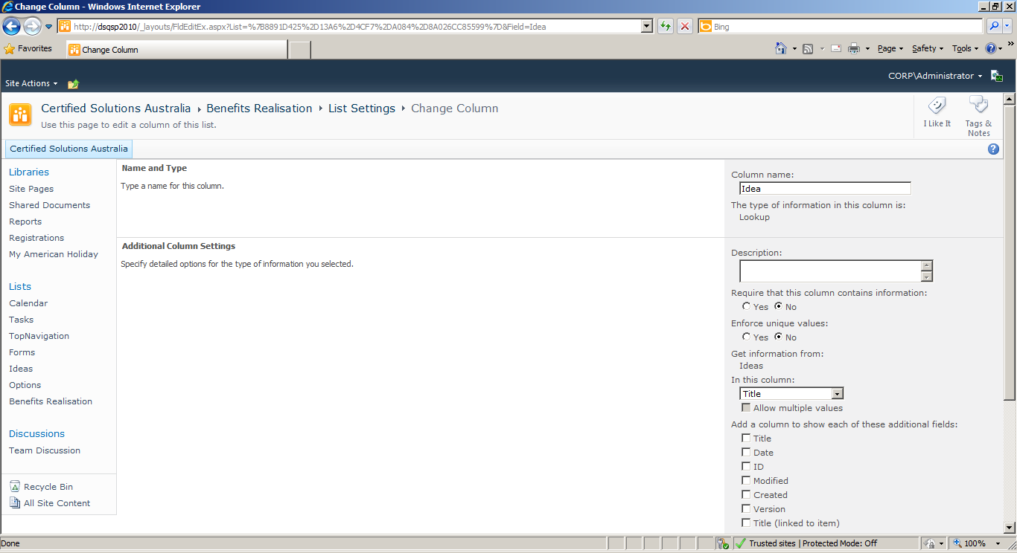
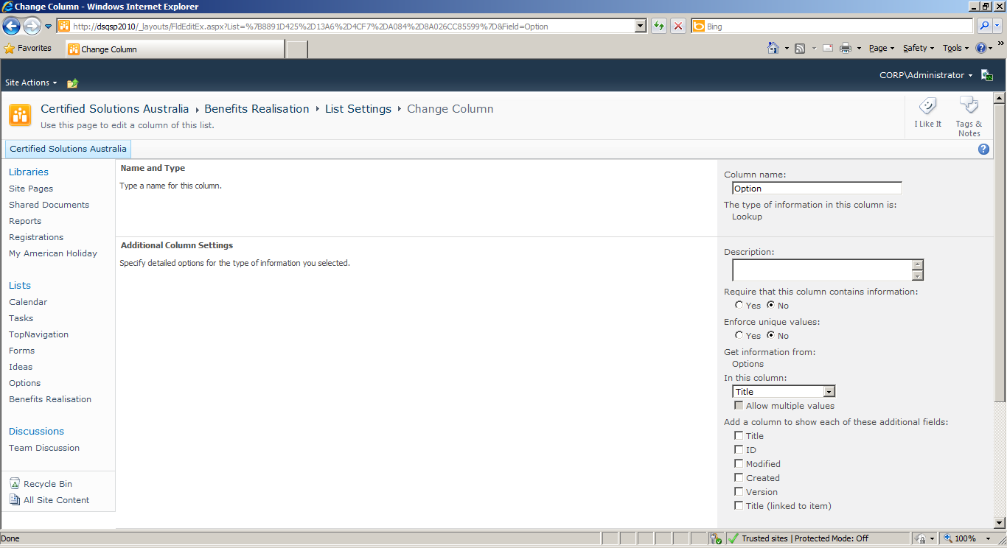

<script language="javascript" src="/Shared%20Documents/jquery-1.3.2.min.js" type="text/javascript"></script><script language="javascript" src="/Shared%20Documents/jquery.SPServices-0.7.1a.min.js" type="text/javascript"></script><script language="javascript" type="text/javascript">
$(document).ready(function() {
$().SPServices.SPCascadeDropdowns({
relationshipList: "Options",
relationshipListParentColumn: "Idea",
relationshipListChildColumn: "Title",
parentColumn: "Idea",
childColumn: "Option",
debug: true
});
});
</script>

